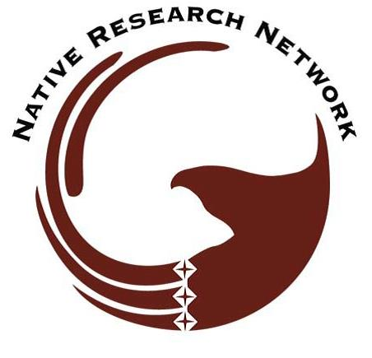
Native Research Network, Inc.
26th National Native Health Research Conference
“Finding the Balance: Sacred Places & Healthy Environments”
Harrah’s Cherokee Resort & Casino - Cherokee, NC
June 5-8, 2016

REGISTRATION FORM

Last Name: _______________________________________First Name: ____________________________
Job title: ______________________________________ Degrees: ______________________________
Tribal Affiliation: _______________________________ Non-tribal member (√) ____
Organization/College/University: ____________________________________________________________
Mailing Address: _______________________________City_______________________ST____ZIP________
Daytime/Mobile phone: ( ) ___________________ Email Address: _______________________________

REGISTRATION FEES:

____ Full Professional Member _____ Early Bird ($300) _____ Regular ($400 after 4/1/16)
____ Student _____ Early Bird ($120) _____ Regular ($200 after 4/1/16)
____ Treasured Friend _____ Early Bird ($300) _____ Regular ($400 after 4/1/16)
____ Non-Member _____ Early Bird ($400) _____ Regular ($500 after 4/1/16)

Daily conference attendance ____$100 per day ____6/5 ____6/6 ____6/7 ____6/8

____ Guests (family, children, spouse) ____$20 for meals (lunch, reception, banquet)

____Exhibitor (Public/Educational) $150
____Exhibitor (Private/Foundation) $300
____Arts & Crafts $50 per table
__________________________________________________________________________________________________

I will need roundtrip Ground Transportation from Airport to Hotel/Conference Center ($50 fee per person).
____ Yes ____No

I will be attending the FREE Pre-Conference Workshop on June 5, 2016 Indian Health Service Institutional Review Board (IRB) Training.
____Yes ____No
__________________________________________________________________________________________________

____ I will be attending the following FREE Conference related activities: (check all that apply)

____Fish Fry Dinner 6/6 (Monday) ____Tour of Great Smoky Mountain National Park 6/7 (Tuesday)

____Tour of Cherokee Indian Hospital 6/7 (Tuesday) ____Tour of Cherokee Museum 6/7 (Tuesday)

Complete and mail with appropriate fee (check or money order) to:
Native Research Network, 2016 NRN Conference Planning Committee, PO Box 982821, Park City UT, 84098

